Riemann–Lebesgue
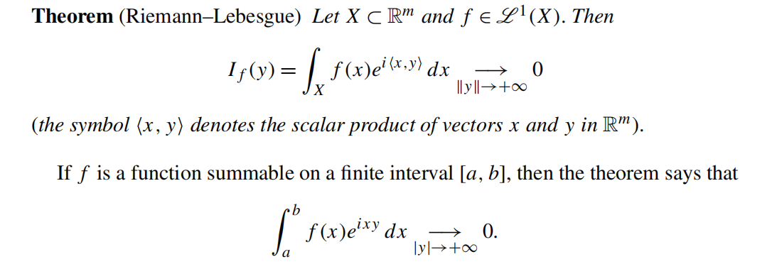
Bessel inequality
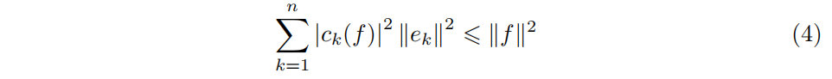
Riesz-Fischer
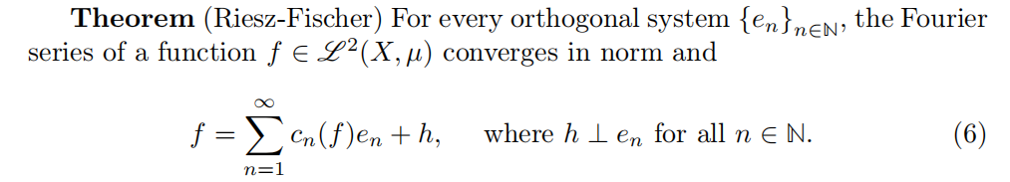
Parseval’s identity

Kolmogorov’s inequality

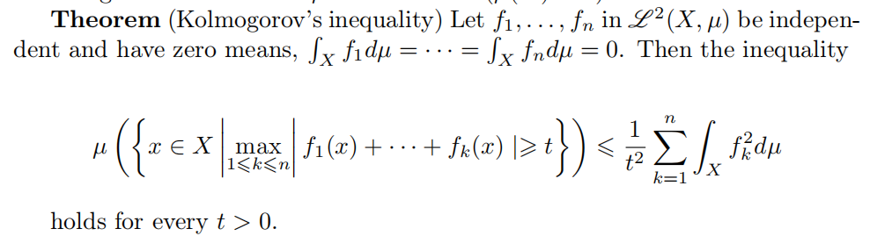
Dirichlet kernel
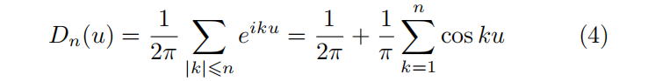
Riemann’s localization principle
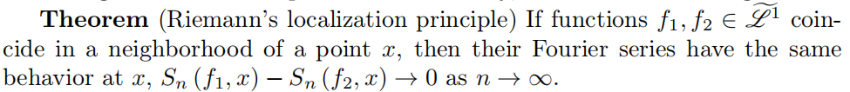
Dirichlet-Jordan test
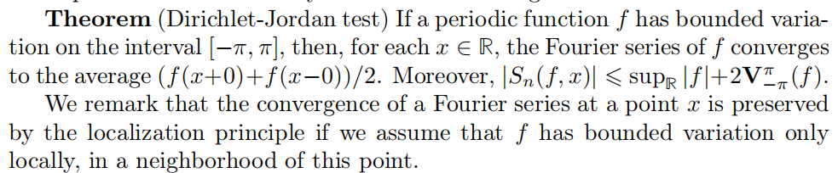Denjoy-Luzin
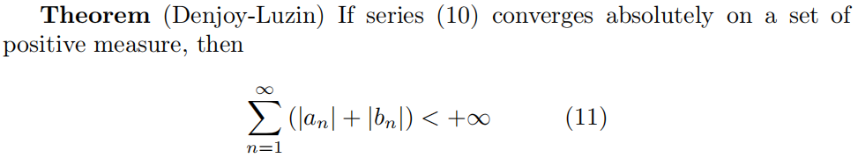
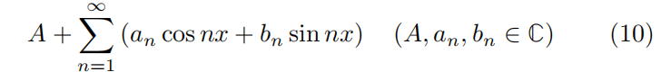
Plancherel
Image measure
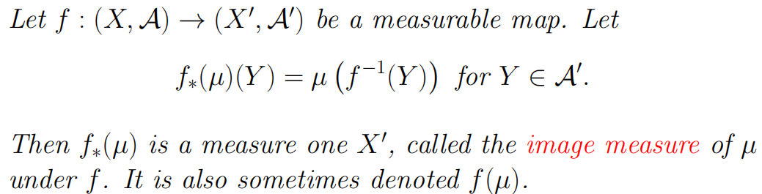
B.Levy monotone convergence theorem
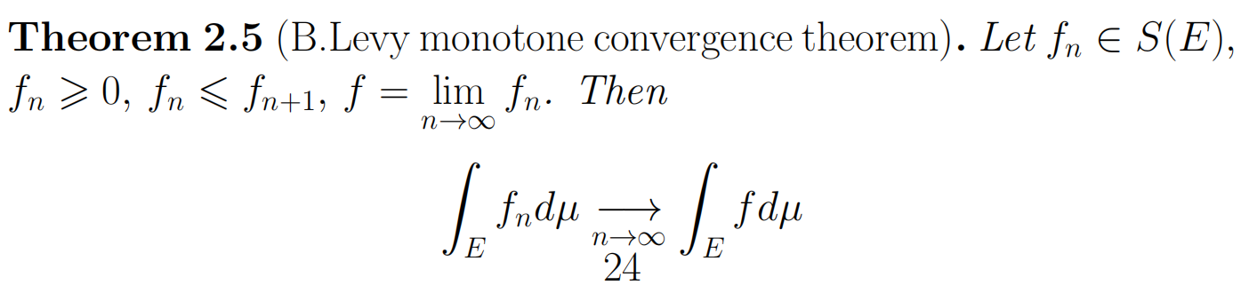
B.Levy theorem for series
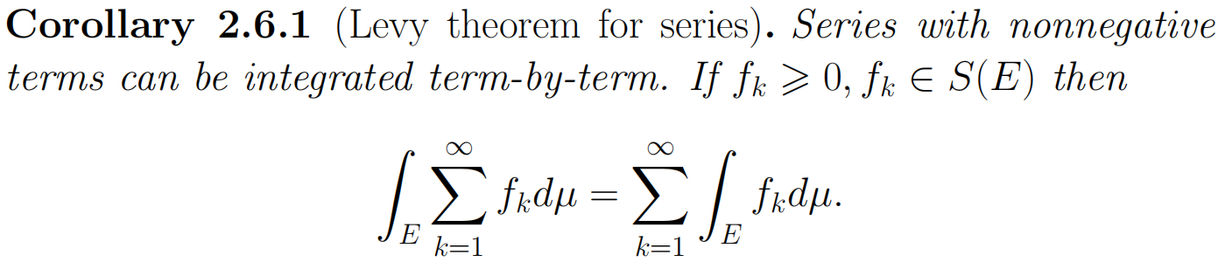
Chebyshev’s inequality
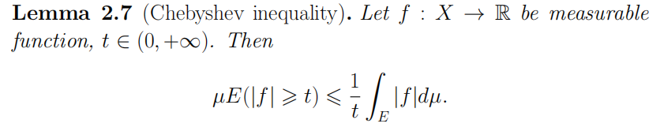
Integral as a measure
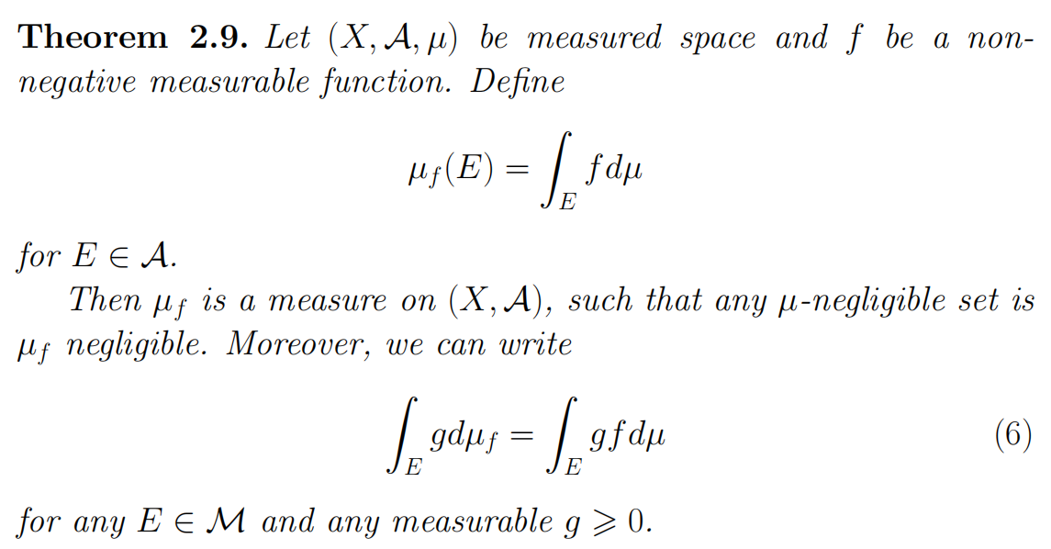

Fatou’s lemma
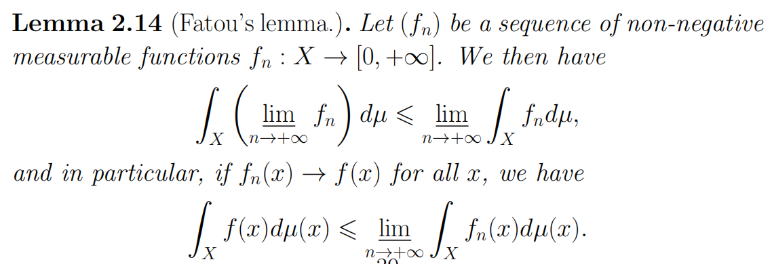
Lebesgue dominated convergence theorem
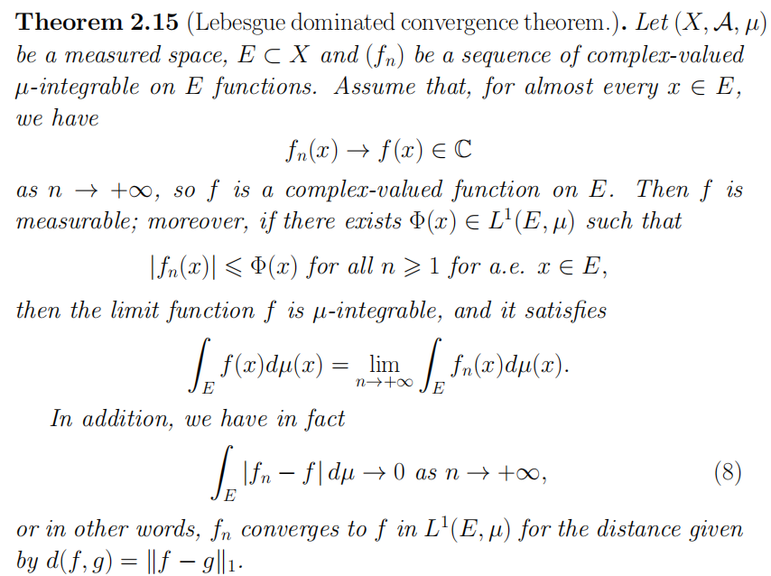
L^{p}-space
Jensen’s inequality
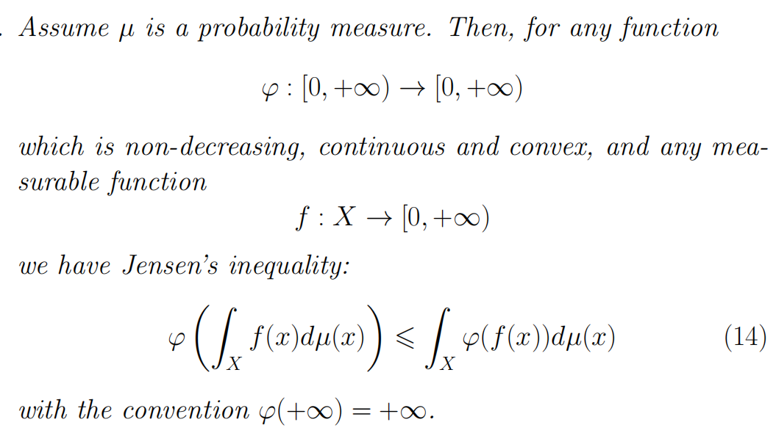
Holder’s inequality
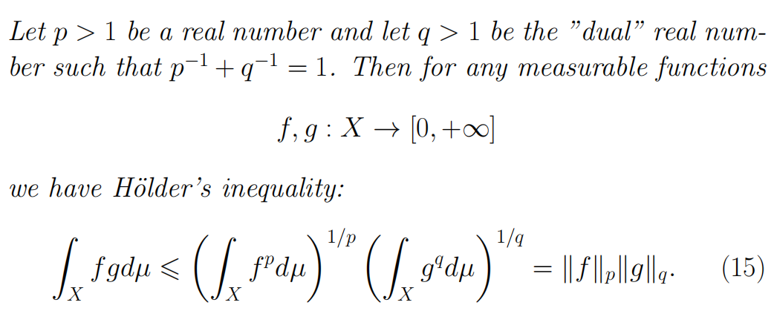
Minkowski’s inequality
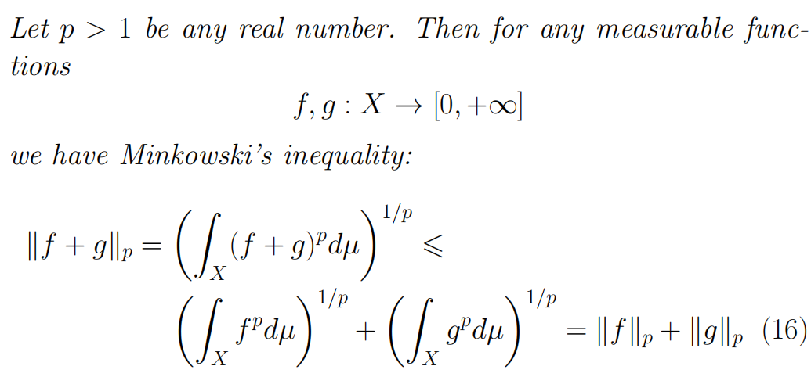
Fubini theorem
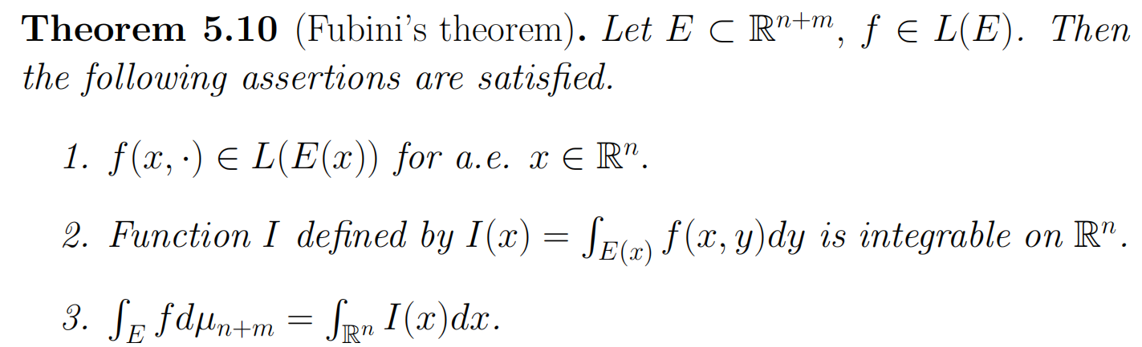
Tonelli theorem
